**Please record: 1) Saturations at end of bagging, 2) Lowest saturations during 1st intubation attempt, and 3) Time between (1) and (2)**

**Optimise patient’s position**

* Neck flexion/extension
* Head position
* Height of bed

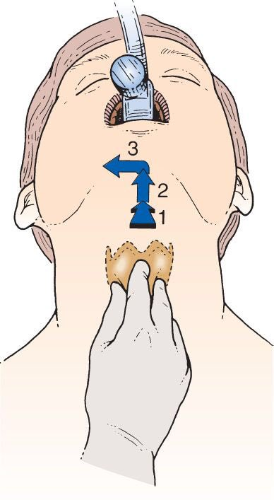

**Cricoid Pressure:**

B - Backwards

U - Upwards

R - Rightwards

P - Pressure

**Apnoeic Oxygenation Flow Rates (standard nasal cannulae):**

<1yr: 5L/min

1-10yr: 8L/min

>10yr: 12L/min